June Week 3 - CONTENT CALENDAR 2025

Day/ Date | Caption / Assets | NOTES | Schedule
 | CAPTION:  Assets: |  | - FB  - IG  - X  - TT
 | CAPTION:  Assets: |  | - FB  - IG
 | CAPTION:  Assets: |  | - FB  - IG  - X  - TT
 | CAPTION:  Assets: |  | - FB  - IG  - X  - TT

 | 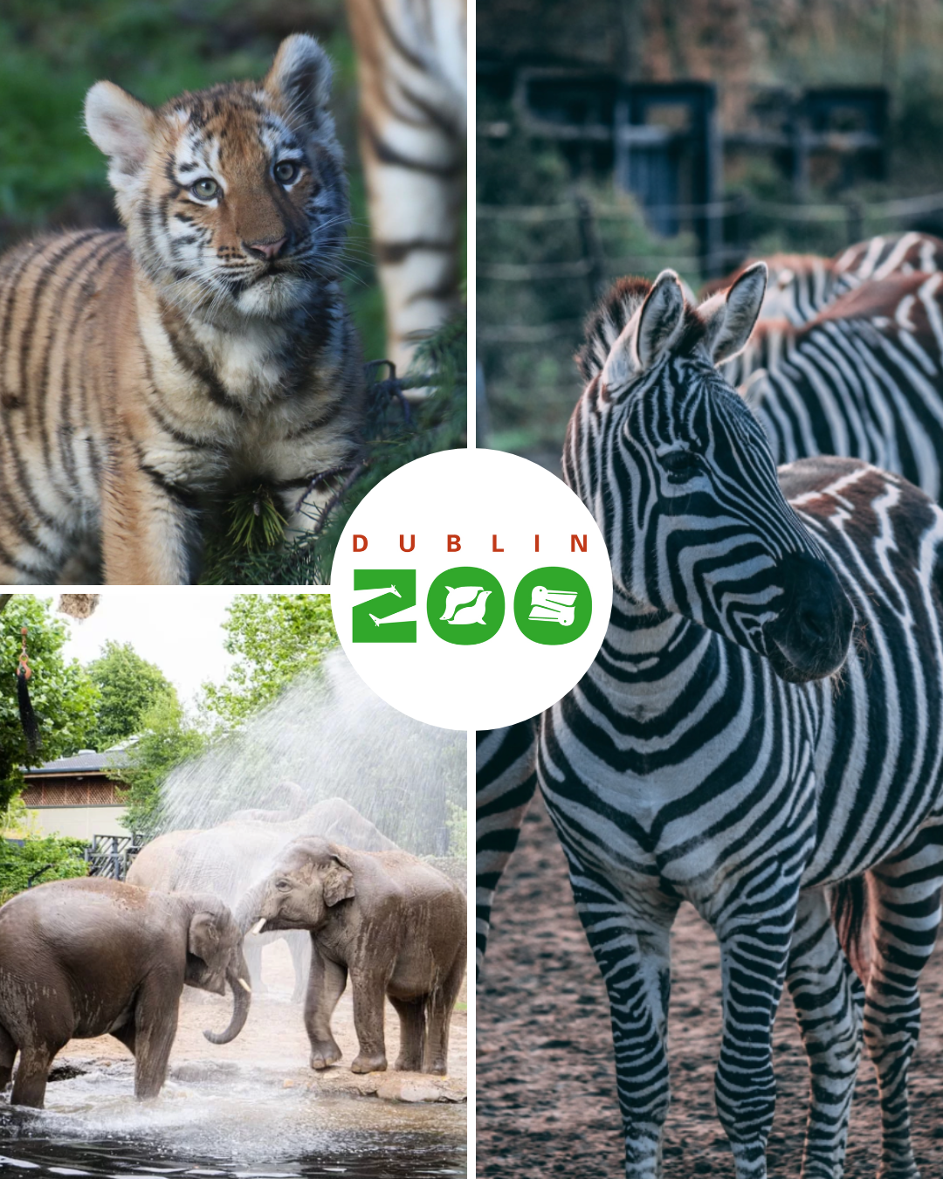 | 
 |  | 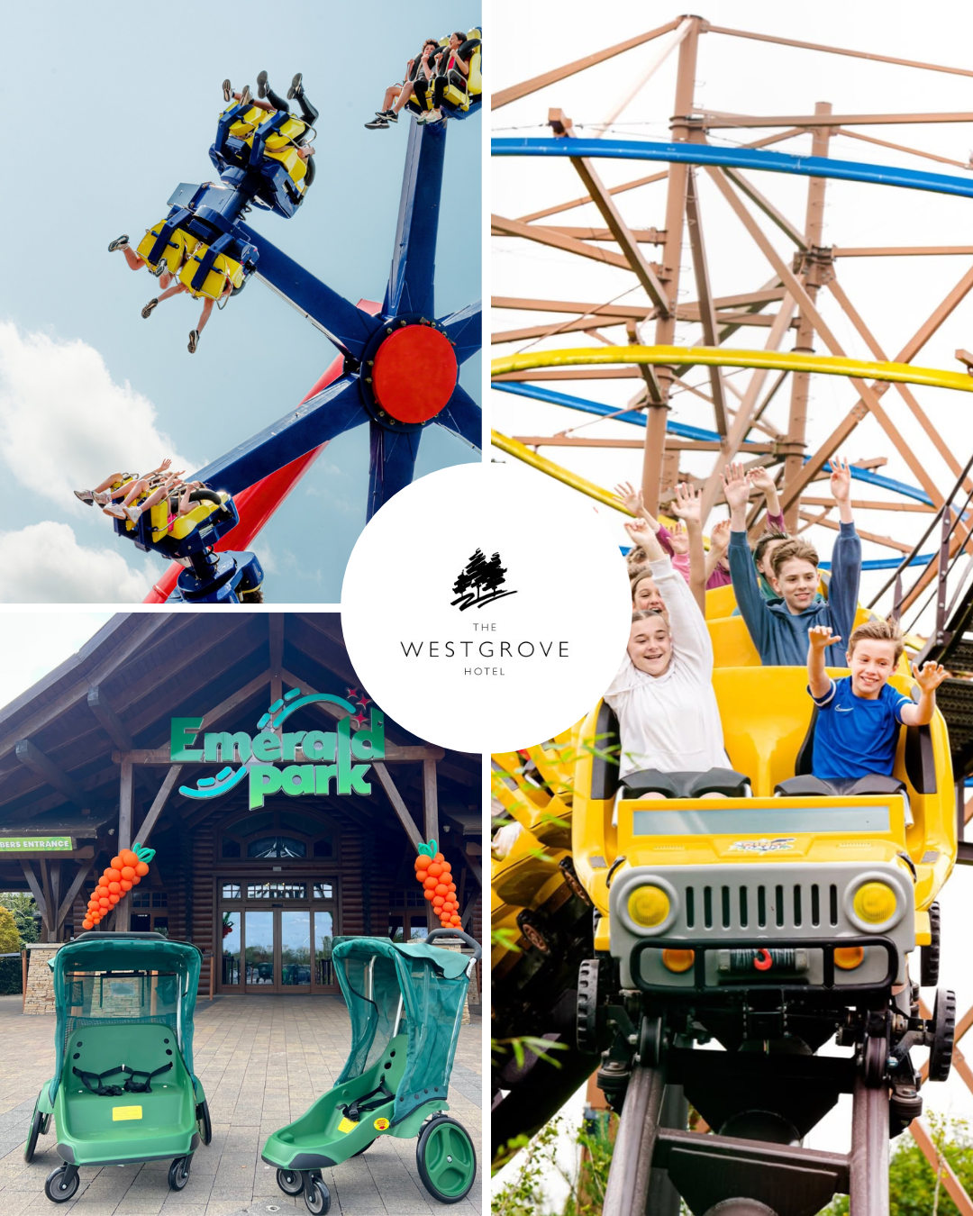

Mae’s notes:
Include Tags for Wedding Posts:
- WeddingsOnline
- Let’s Talk Weddings
- WeddingSuppliers
- Bridebook

Tags for Hotel Posts:
- @millicent_golf_club

